COSC411 HW #2

Uninformed & Informed Search – JJ McCauley

# Problem #1

## DFS

Data Structure: Stack

Expansions:

1. Fringe: B, C, D
2. 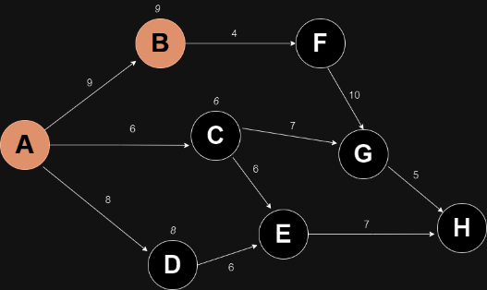A black and white diagram with white letters and numbers

   Description automatically generatedFringe: F, C, D
3. 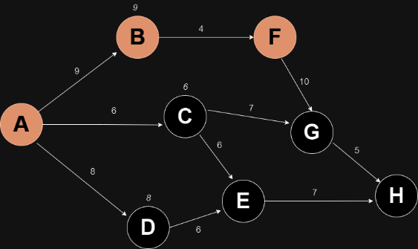Fringe: G, C, D
4. 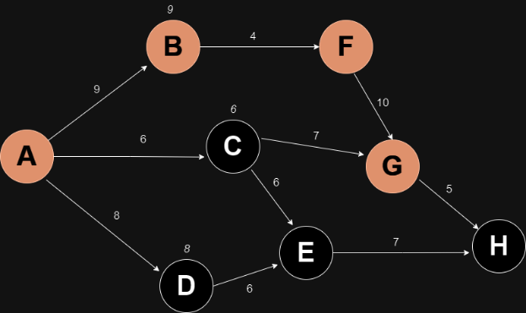Fringe: H, C, D
5. 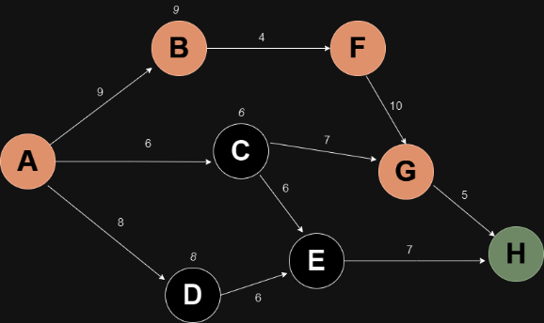GOAL STATE ACHIEVED

## BFS

Data Structure: Queue

Expansions:

1. 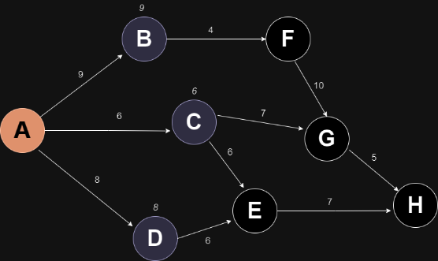Fringe: D, C, B
2. 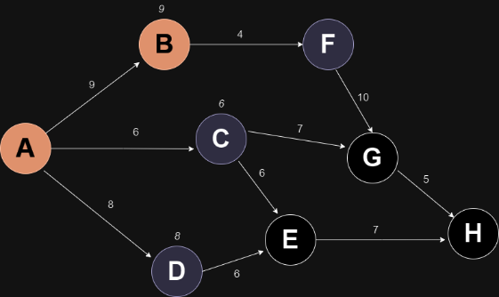Fringe: F, D, C
3. 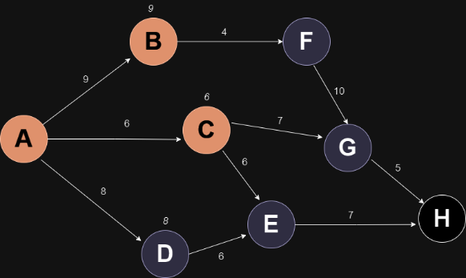Fringe: E, G, F, D
4. 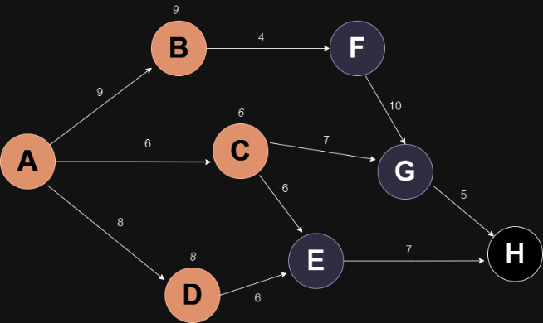Fringe: E, G, F
5. 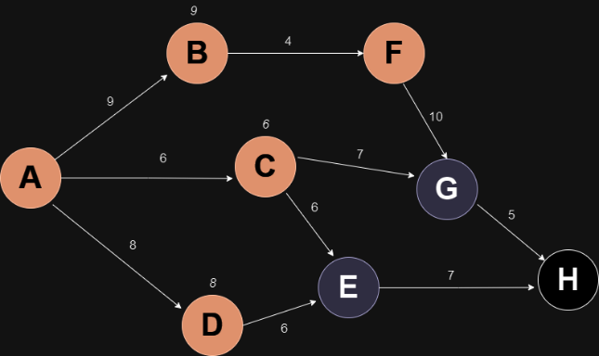Fringe: E, G
6. 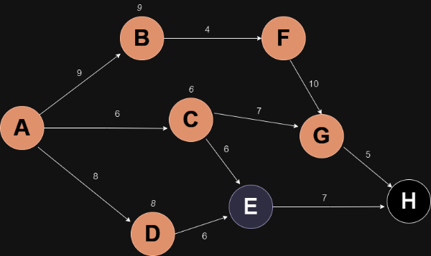Fringe: H, E
7. 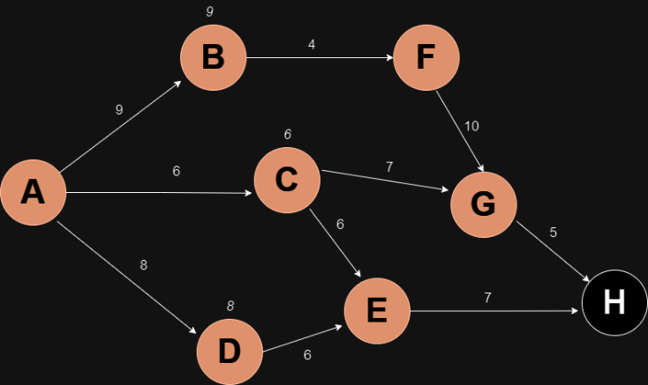Fringe: H
8. 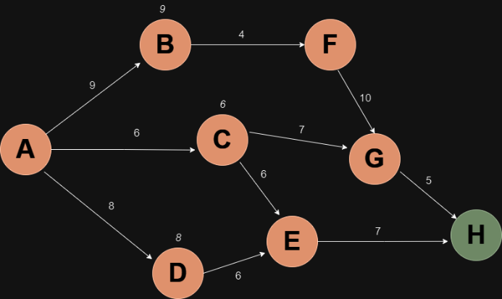GOAL STATE ACHIEVED

## Uniform Cost Search (UCS)

Data Structure: Priority Queue (based on cost)

Expansions:

1. 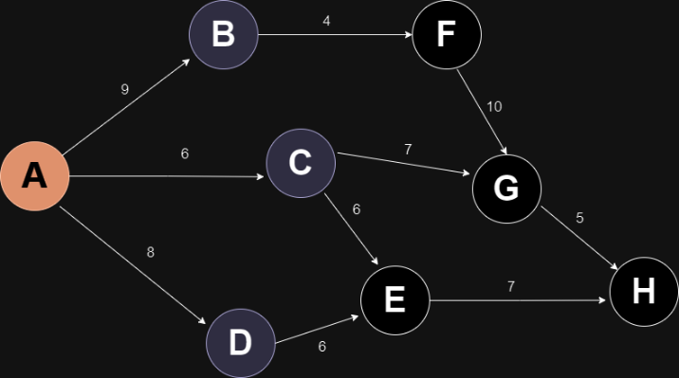Expanding A | Fringe: (B, 9), (D, 8), (C, 6)
2. 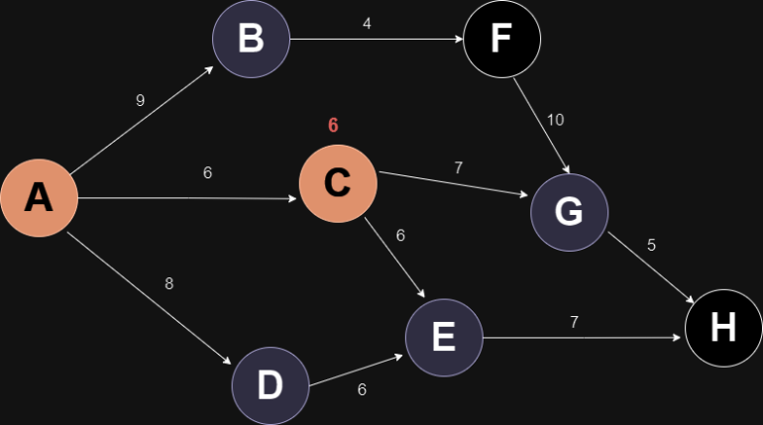Expanding C | Fringe: (G, 13), (E, 12), (B, 9), (D, 8)
3. 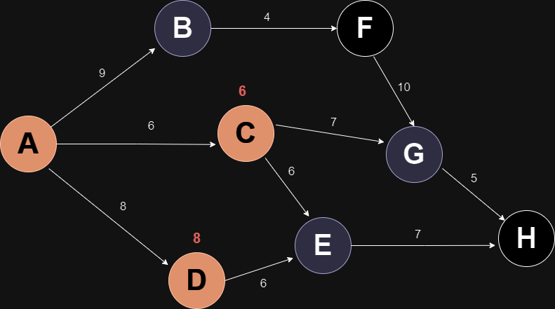Expanding D | Fringe: (G, 13), (E, 12), (B, 9)
4. 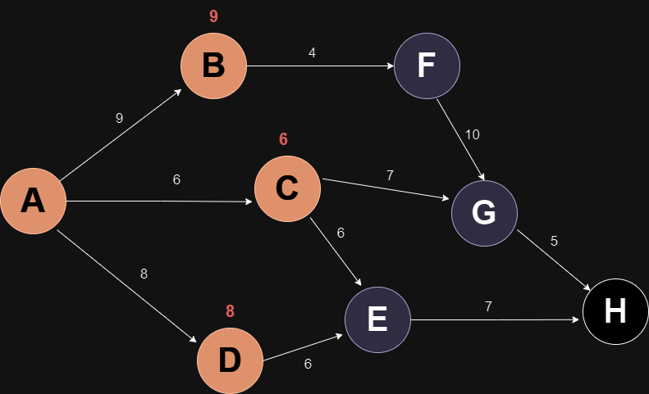Expanding B | Fringe: (G, 13), (F, 13), (E, 12)
5. 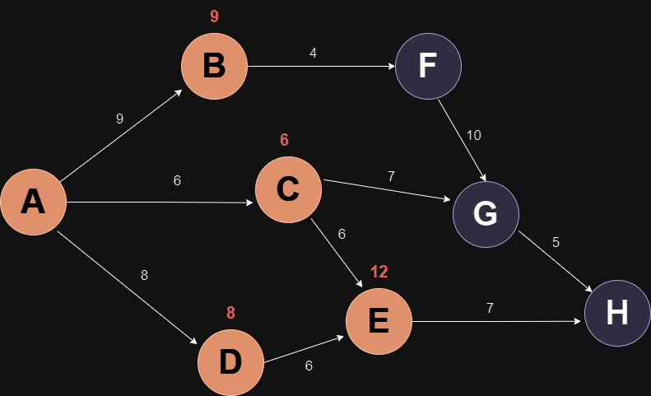Expanding E | Fringe: (H, 19), (G, 13), (F, 13)
6. 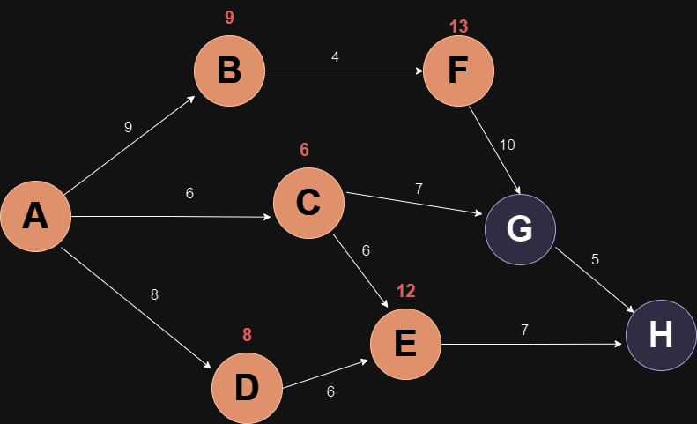Expanding F | Fringe: (H, 19), (G, 13)
7. 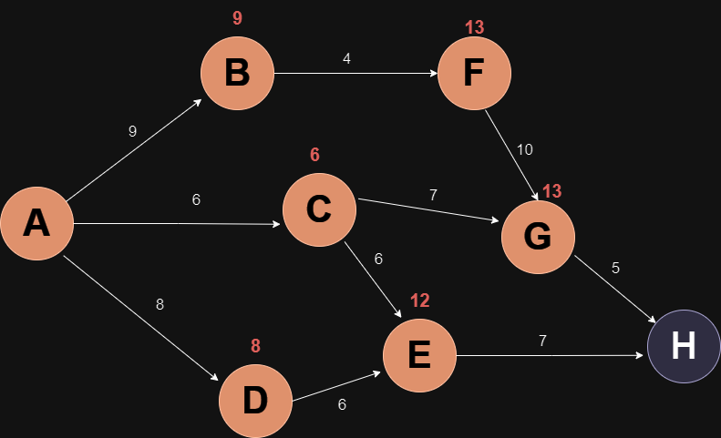Expanding G | Fringe: (H, 18)
8. 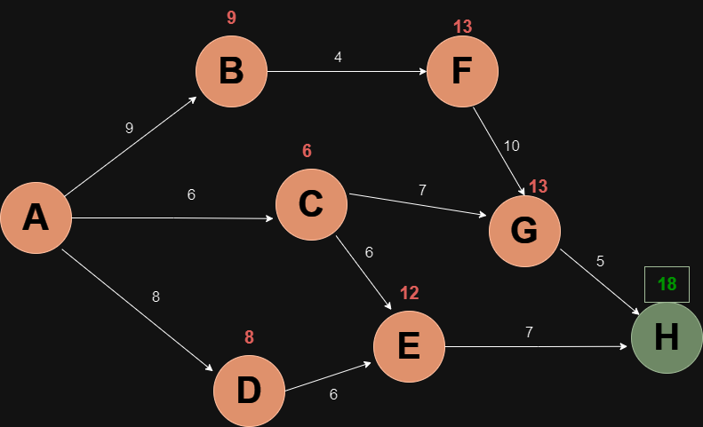Fringe: Empty | END STATE REACHED

## Greedy Search

Data Structure: Priority Queue (based on heuristic function)

Expansions:

1. A diagram of a network

   Description automatically generatedExpanding A | Fringe: (B, 20), (D, 13), (C, 11)
2. 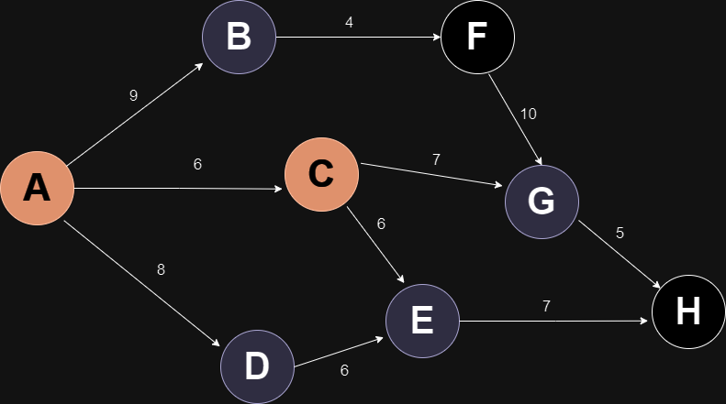Expanding C | Fringe: (B, 20), (D, 13), (E, 6), (G, 2)
3. 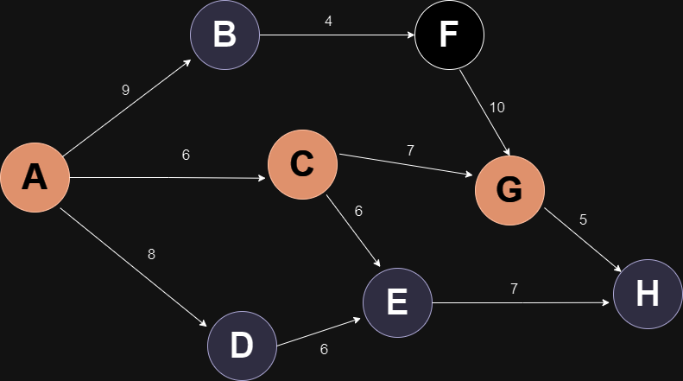Expanding G | Fringe: (B, 20), (D, 13), (E, 6), (H, 0)
4. 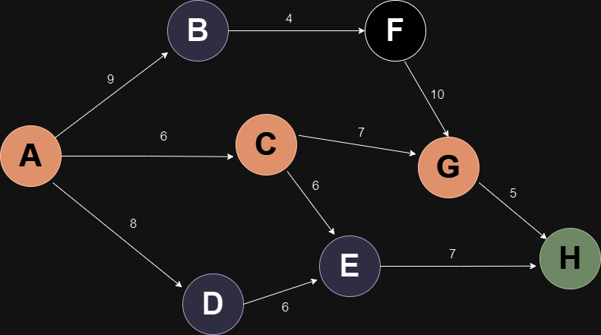END STATE REACHED

## A* Search

Data Structure: Priority Queue

Expansions:

1. A diagram of a network

   Description automatically generatedExpanding A | Fringe: (B, 29), (D, 21), (C, 17)
2. 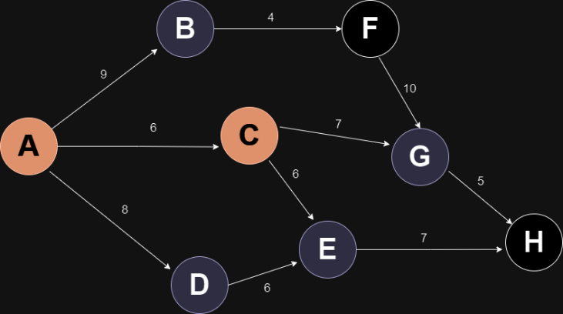Expanding C | Fringe: (B, 29), (D, 21), (E, 18), (G, 15)
3. 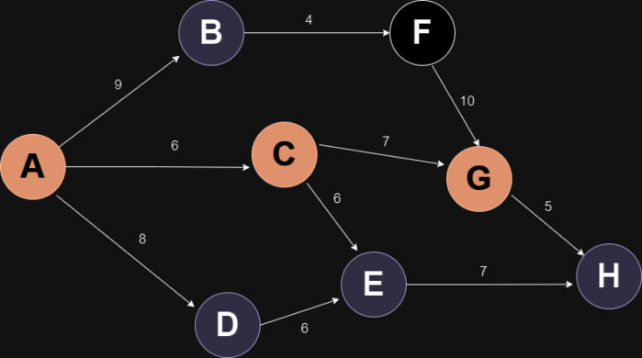Expanding G | Fringe: (B, 29), (D, 21), (E, 18), (H, 18)
4. 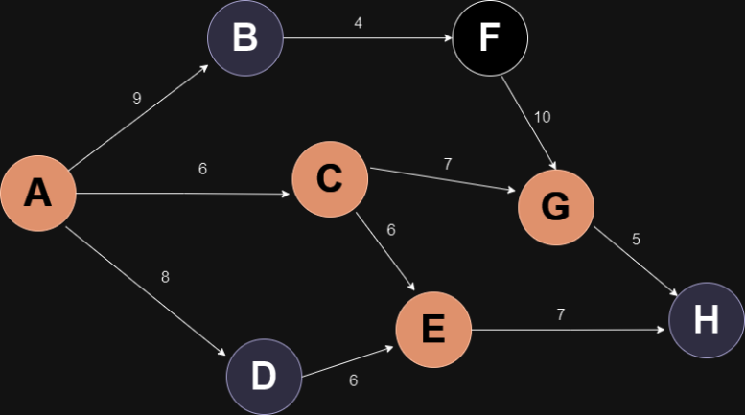Expanding E | Fringe: (B, 29), (D, 21), (H, 18)
5. 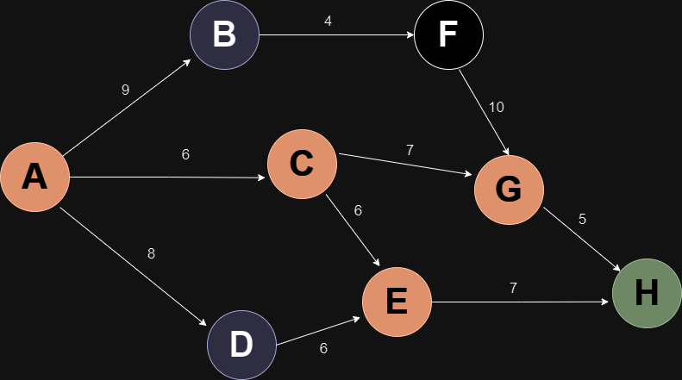END STATE REACHED